Data Management and Sharing Plan (DMSP) Guidelines
Prepared by the Office of Research | Updated April 30, 2026 | For Internal Use

Overview
Proposals submitted to many federal funding agencies (and some foundations) require a data management plan. This includes the National Science Foundation (NSF) and the National Institutes of Health (NIH). As the federal government continues to expand accountability and reporting requirements for grants and contracts, it is likely that additional agencies (with the exception of DoD) will impose data management and sharing requirements on principal investigators.
This document provides blank NSF and NIH templates that can be freely copied and edited into grant proposals submitted from Syracuse University.

Further Assistance
The Office of Research recommends the following steps for obtaining further assistance with developing a data management plan.
- Consult with colleagues in your department, school, or college who have submitted to the same funder, and ask them to share their data management plans.
- Ask your Office of Research Development contact for access to exemplary data management plans they may have collected.
- Contact the Office of Sponsored Programs staff at least three weeks in advance of your proposal submission deadline for project-specific support, recommendations, and answers to your questions.

Part I: NSF Data Management and Sharing Plan

NSF Policy Updates
As of April 27, 2026, NSF replaced the traditional DMSP PDF attachment with a structured webform integrated directly into Research.gov, as outlined in NSF PAPPG 24-1, Supplement 2.
Key points:
- The DMSP is required to be submitted with all NSF proposals unless a justification for exemption is provided.
- As of April 27, 2026, the DMSP must be completed using the Research.gov webform.
- The webform will be tailored to the proposal’s primary Directorate.
- A template is available at https://www.research.gov/research-web/content/DMSP.

NSF Template (taken from Research.gov on April 30, 2026.)

Data Management and Sharing Plan
Complete the Data Management and Sharing Plan for the primary Directorate you are applying to, or provide a justification if a detailed Data Management and Sharing Plan is not needed. Refer to the funding opportunity for specific guidance on how to complete this section. This section may not be used to circumvent the Project Description page limit.
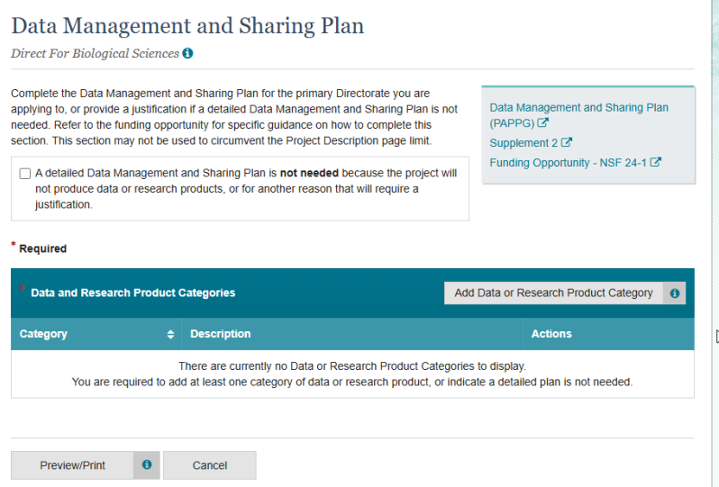
Data or Research Product Category General Information
Each distinct category should receive its own entry. Please note that this does not require that each dataset or type of data receive its own entry. Rather, it is sufficient simply to specify each high-level category. For example, many data categories may incorporate several different types of data that are all aligned for the purposes of the project. This organization may vary by field and even by project.

In the title, PIs should either select a predefined title that matches well with the intended data category or provide such a title through the “Add New” mechanism if one is not available (see 8).

In the description, PIs should provide additional detail about the category that they feel is necessary. Keep in mind that for predefined options, little additional detail may be necessary.

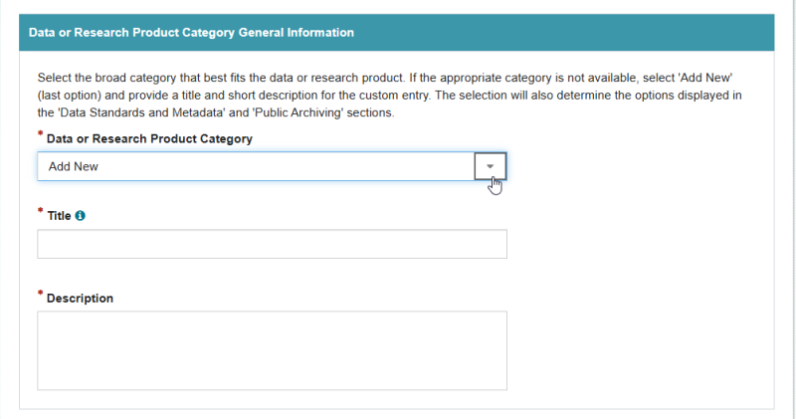

Access Policies and Limitations
For each data or research product category, any applicable limitations on the sharing of data or research products associated with that category must be provided. An extensive, but non-exhaustive, set of pull-down options is provided. If no limitations are anticipated, “Not Applicable” should be checked. Note that several options can be selected in this section if more than one applies to the category. This information will be used during review to assess the reasonableness of any exceptions to the expectation that data will be shared.
In the title, PIs should either select a title that matches well with the limitation or provide such a title through the “Add New” mechanism if one is not available.

In the description, PIs should provide any additional detail about limitations they feel necessary. Keep in mind that for predefined options, little additional detail may be necessary.
Note: Unless 'Not Applicable' is selected, an explanation and justification of the concern must be provided below.

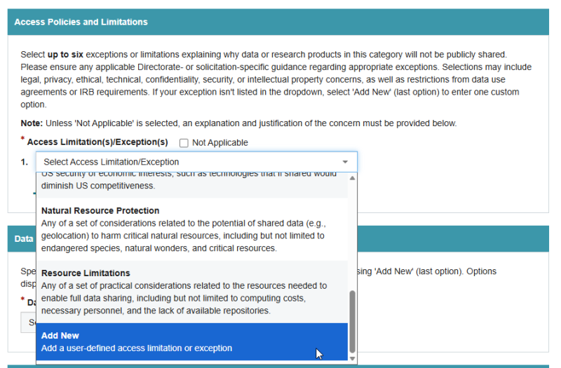

Data Standards and Metadata
For each data or research product category, PIs should use this section to provide information about the format and/or metadata associated with the shared product. Many data or research product categories already have formatting standards and those should be specified here. If such a standard is not available, then the DMSP should specify relevant data formatting information as appropriate.

In the title, PIs should either select a title that matches well with the standard or provide such a title through the “Add New” mechanism if one is not available.

In the description, PIs should provide any additional detail about the standard that they feel is necessary. Keep in mind that for common options, little additional detail may be necessary.

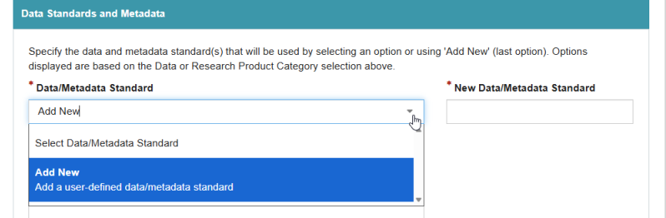
Data or Research Product Provenance
For each data or research product category, PIs should use this section to provide information about the source of data or research products associated with the category. In many cases, the source of the data will be a “New Data Collection” managed by the researcher, though there are other cases (e.g., data reuse, shared facility).

In the title, PIs should either select a title that matches well with the source or provide such a title through the “Add New” mechanism if one is not available. In the case of data reuse or the use of a shared facility, the name of the resource should be provided here.

In the description, PIs should provide any additional detail about the standard that they feel is necessary. Keep in mind that for common options, little additional detail may be necessary.
Note: If data is coming from an existing dataset or existing data resource, it must be identified below.

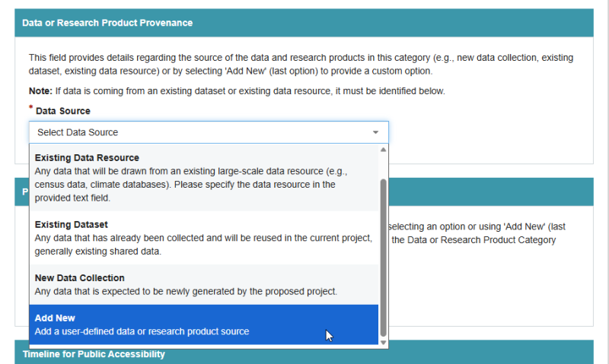

Public Archiving
For each data or research product category, PIs should use this section to provide information about where data or research products associated with this category will be shared (If applicable). In many cases for digital data, this sharing will be via an online repository.

In the title, PIs should either select a title that matches well with the sharing location (e.g., repository title) or provide such a title through the “Add New” mechanism if one is not available. Note that sharing through institutional resources (e.g., lab webpages) can be denoted as “Institutional Repository” through “Add New” if needed.

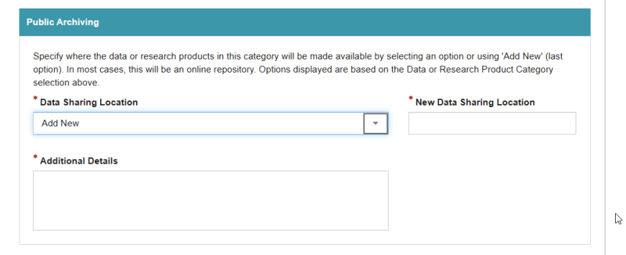
In the description, PIs should provide any additional detail about the location that they feel is necessary. Keep in mind that for common options, little additional detail may be necessary.
Timeline for Public Accessibility
For each data or research product category, PIs should use this section to provide information about when data or research products associated with the category will be shared (If applicable). In many cases, the data or research products associated with the category will be shared at the time of publication, though other options are allowable as needed. PIs are responsible for confirming that the selections they make are consistent with data management and sharing guidance for the unit of consideration for the proposal.

In the title, PIs should either select a title that matches well with the sharing timeline or provide such a title through the “Add New” mechanism if one is not available. In cases where there is some complexity in the intended sharing timeline (e.g., different timelines for different subsets of data within the category), then the “Add New” mechanism may be the best way to address this subtlety.

In the description, PIs should provide any additional detail about the timeline that they feel is necessary. Keep in mind that for common options, little additional detail may be necessary.

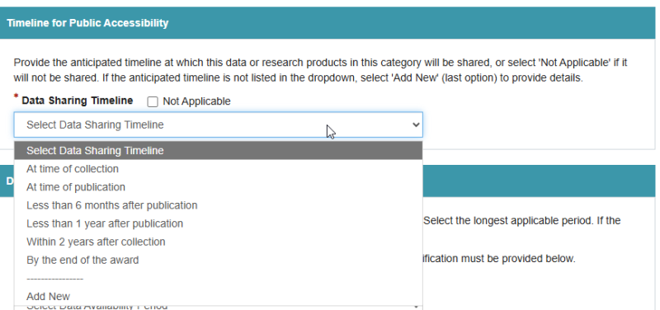

Data Availability
For each data or research product category, PIs should use this section to provide information about the duration for which data or research products associated with this category will be retained (If applicable). In many cases, the retention duration will be determined by the policies of the repository. If that is the case, the radio button for that option should be selected and no further information is required. If no such policy is applicable, then the researcher can provide the information via the usual pulldown and “Add New” mechanism.

In the title, PIs should either select a title that matches well with the sharing duration or provide such a title through the “Add New” mechanism if one is not available.

In the description, PIs should provide any additional detail about the retention duration that they feel is necessary. Keep in mind that for common options, little additional detail may be necessary.
Note: If the availability of the data is less than two years after project completion, a justification must be provided below.

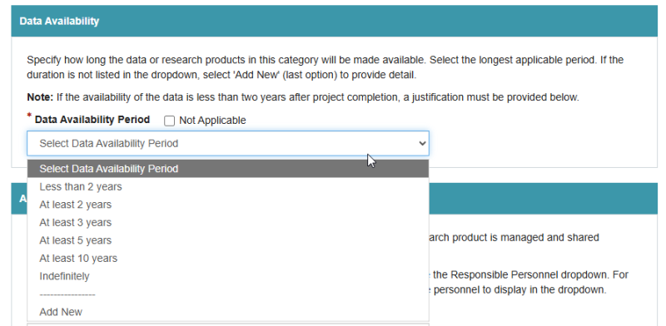

Accountability
For each data or research product category, PI or co-PI should use this section to provide information about who among the Senior Personnel will be responsible for the sharing of data or research products associated with the category. In this case the available options (i.e., the Senior Personnel associated with the project) are prepopulated from the proposal itself.

Note: Add personnel from Manage Personnel and Subaward Organizations to populate the Responsible Personnel dropdown. For separately submitted collaborative proposals, non-lead proposals must be linked for the personnel to display in the dropdown.

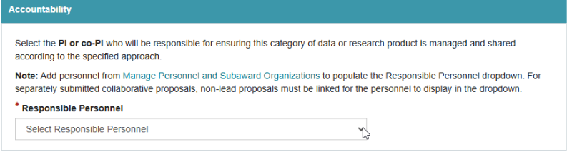

Part II: NIH Data Management and Sharing Plan

NIH Policy Updates
Effective May 25, 2026, NIH will implement an updated format for DMSPs (NOT-OD-26-046). While the underlying 2023 NIH Data Management and Sharing Policy remains unchanged, this new format reflects NIH’s broader effort to reduce administrative burden and improve consistency in how plans are written, reviewed, and monitored.
Key points are as follows.
- The DMSP is required for all proposals that will generate scientific data.
- The 2026 Pilot DMSP format (.docx) is available for immediate use.
- The current two-page narrative will be replaced by a standardized format with Yes/No questions, requiring explanations only for “No" responses or when sharing will be limited.
- A helpful resource is NIH’s Writing a Data Management and Sharing Plan.

NIH Template (taken from the NIH website on April 30, 2026)

- Will there be maximum appropriate sharing of scientific data underlying peer-reviewed publications and other findings resulting from the work supported by this award (including preprints, refereed papers reported at conferences, and other findings)?
Yes ☐ No ☐
- Will the scientific data underlying peer-reviewed publications be shared by the time of publication, or for other findings, by the end of the period of performance, which includes no-cost extensions?
Yes ☐ No ☐
- Will shared scientific data be made available for at least as long as required by applicable data repository policies and/or journal policies?
Yes ☐ No ☐
- If you answered “No“ to Elements 1, 2, or 3, or if you anticipate that sharing will be limited in some other way, please describe these limitations and the ethical, legal, or technical factors for them. Your response should specify a particular reason for limiting sharing. [300 words maximum]
- If scientific data derived from human research participants will be shared, will privacy, rights, and confidentiality of participants be protected as outlined in NOT-OD-22-213?
Yes ☐ No ☐ Not Applicable ☐

- In the table below, please list [100 words maximum]:
  - Key types of scientific data anticipated to be generated during the project, including the species and modality, if known (e.g., “human genomic data,” “rat functional magnetic resonance imaging data”). NIH recognizes that not all data types expected to be generated in the study will meet the definition of scientific data or can be anticipated in advance. If a data type does not appear on the list, it does not imply that that data type will not be shared if it is generated in the study.
  - The repository or an example of a repository where the scientific data may be managed and shared, if the scientific data is known at time of application. NIH expects the use of established repositories for preserving and sharing scientific data when they are available.
Expected Data Type | Established Repository or Example

- For studies subject to the NIH Genomic Data Sharing Policy (GDS) (e.g., using NIH funds to generate large-scale human genomic data):
  - Will you share all large-scale human genomic and associated data in a NIH-designated repository according to the accelerated timelines expected in the GDS Policy?
Yes☐ No☐ Not Applicable☐
If “no,” address in element 4.
  - Do you anticipate that when sharing you will be able to meet the expectations of the Institutional Certification in the GDS Policy?
Yes☐ No☐ Not Applicable☐
If “no,” address in element 4.

